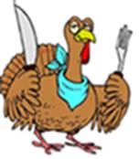


Date: Monday, November 25, at 12:00 Noon

Set-up Volunteers: ___________ ________ _________

Clean-up Volunteers: __________ __________ ________

Suggested Menu Items:
(These are just suggestions – please feel free to bring other items. Please bring enough to share.):

Appetizers: Appetizers:

Turkey Slices: Ham Slices:

Other Meats: Vegetable Dish:

Vegetable Dish: _____ Sweet Potatoe Dish: _

Green Salad with Salad Dressing: _________ Other Dish:

Mashed Potatoes: ____ Gravy for Mashed Potatoes:
Stuffing: __ Cranberry Sauce: ___

Mac & Cheese: Green Bean Casserole:

Mac Pie: Bean Salad:

Drinks (Ice Tea or Lemonade): Ginger Ale:

Pumpkin Pie: __________________ Apple Pie: ______________

Thank You!

